**Heart Disease Analysis**

**Overview**

This project was done in a learning perspective to check the age criteria in which most of the heart diseases occur and its corresponding reasons.

It was done in R programming language using tidyverse package.

**Table Content**

* Data - 303 rows and 14 columns
* Age Patient Age
* Gender 0=Female, 1=Male
* Type of Chest Pain 1=Typical Angina, 2=Atypical Angina, 3= Not Angina Pain, 4=Asymptotic
* Serum Cholesterol This is measured in mg/dl
* Resting Blood Pressure If it is very high the chances of getting heart attack is very high
* Fasting Blood Sugar Fasting blood sugar>120 mg/dl (0=False,1=True)
* Maximum Heart Rate The value of the maximum heart rate
* Resting ECG 0=Normal, 1=Having ST-T Abnormality,2=Left Ventricular Hypertrophy
* Thalassemia 3=Normal, 6=Fixed Defect, 7=Reversible Defect
* Peak Exercise ST Segment 1=Having pain, 0=Not having Pain
* Diagnosis of Heart Disease 0=Absence,1=Present

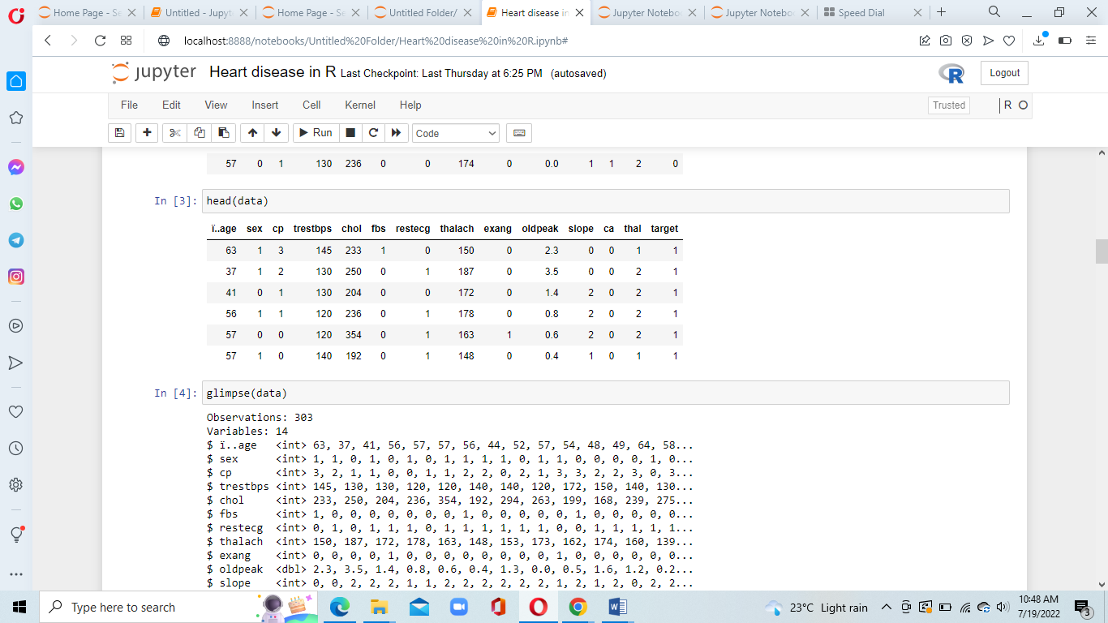

**Data Cleaning** (dplyr)

The data taken from the dataset was very vague it order to make in user understandable cleaning was done.

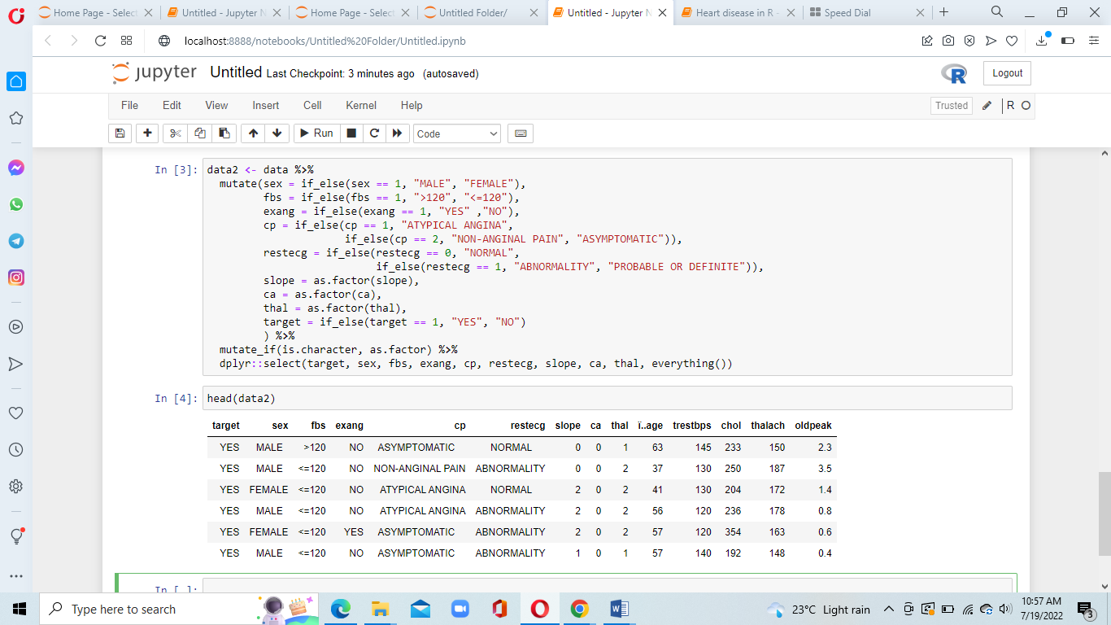

**Data Visualizations** (ggplot)

1. Count of how many people have heart diseases

* Out of 303 entries more than 150 people suffer from heart diseases.
* It occurs in a certain range of age 50 to 65

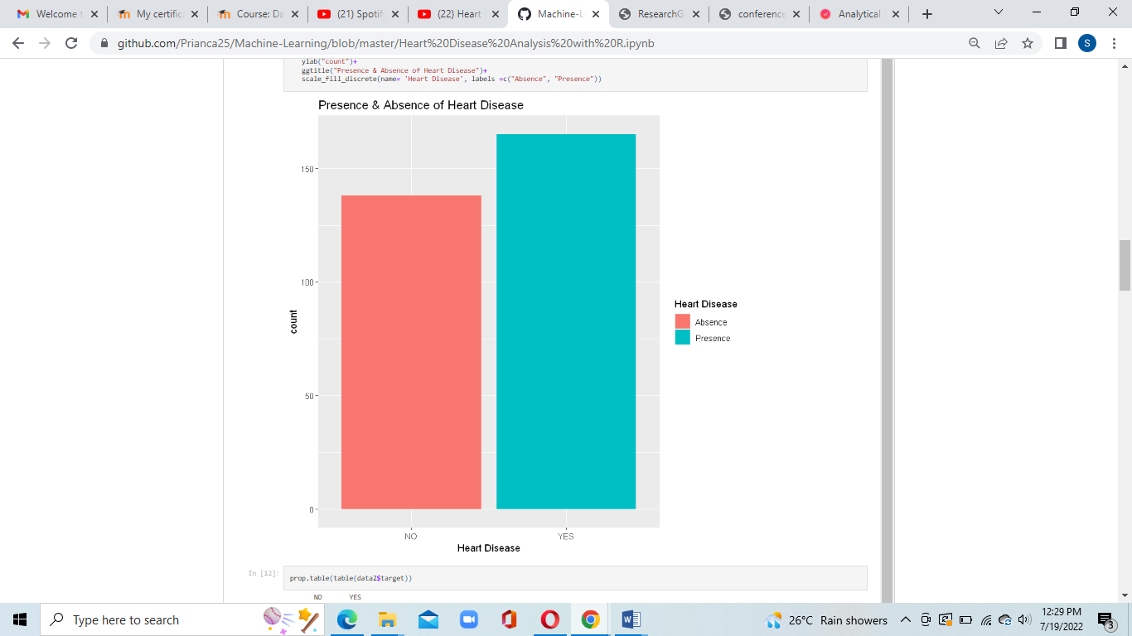

1. Frequency in the age

* It occurs in a certain range of age 50 to 65
* More than 15 people have heart issues in the age criteria 53-60

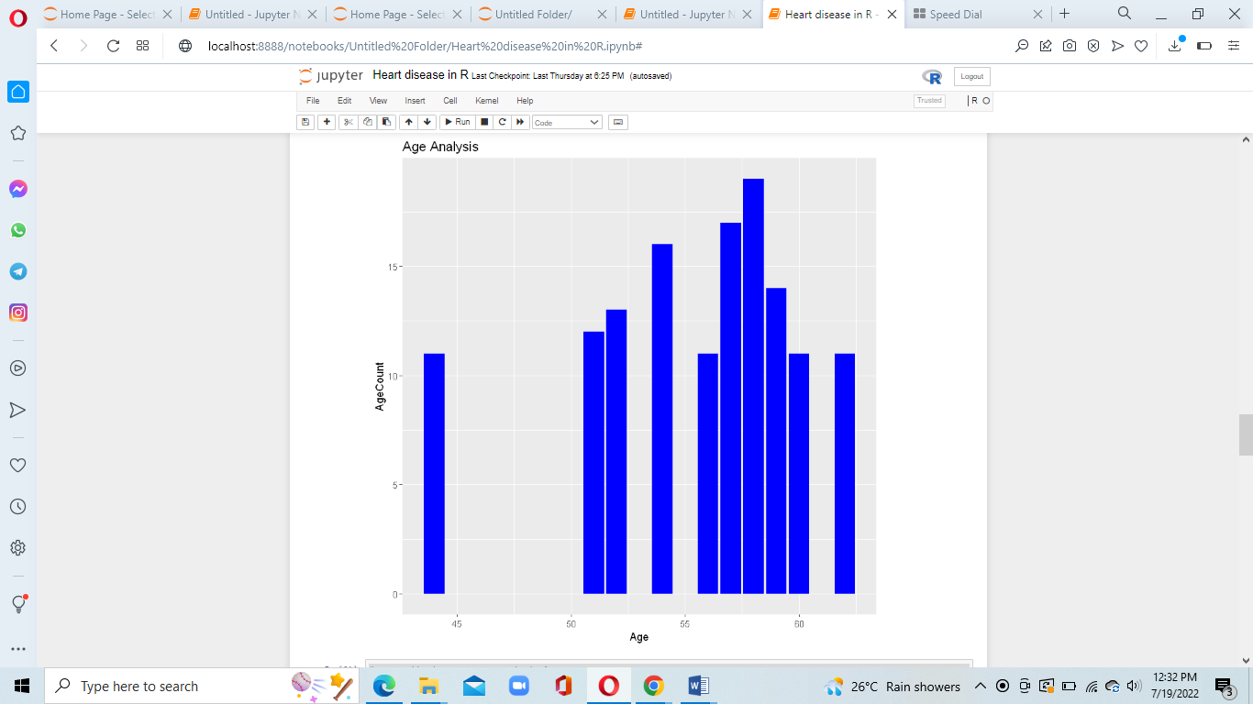

1. Blood Pressure across Chest pain

* It shows that female having a blood pressure above 150 are more prone to asymptotic chest pain
* In case of men having blood pressure more than 150 are prone to atypical chest main and more of the men are prone to even non agnail pain.
* It shows that female that have cholesterol range between 250 to 300 are more prone to asymptomatic chest pain.
* And men in range of 220 to 250 have asymptomatic chest main.

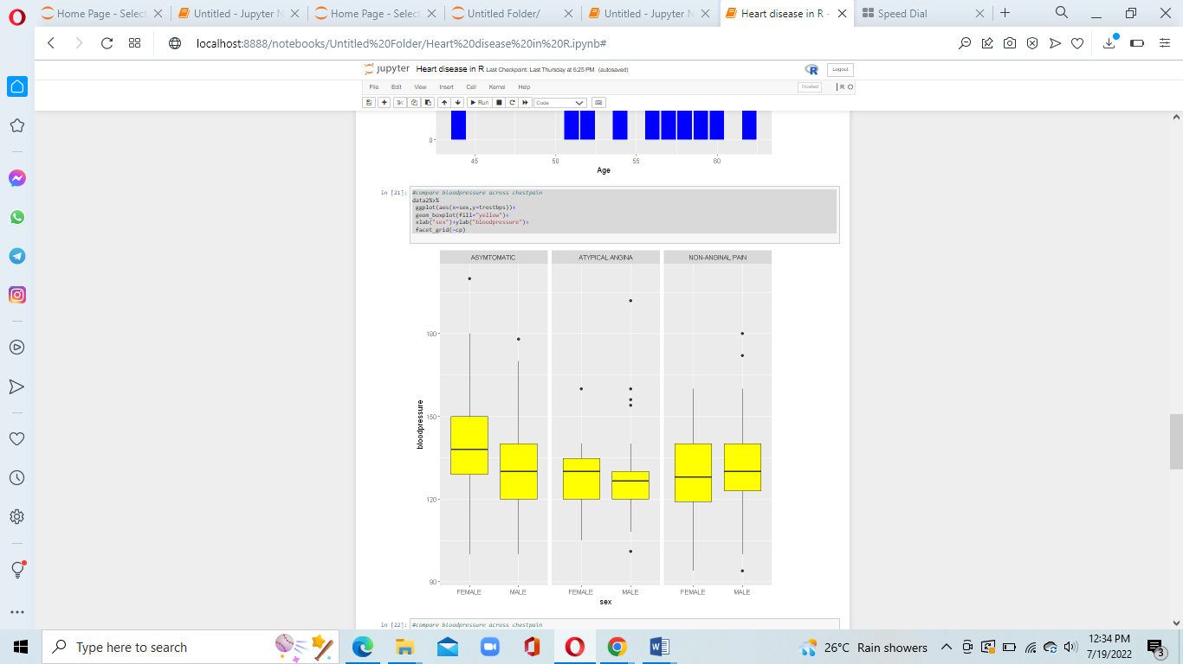

1. Blood Pressure across Cholesterol

* Women having a cholesterol rate more than 400 are prone to non-angina pain and with cholesterol above 500 extreme high chances of heart diseases.
* Female having cholesterol above 250 -300 and 250-290 for men have high chances of asymptomatic condition.

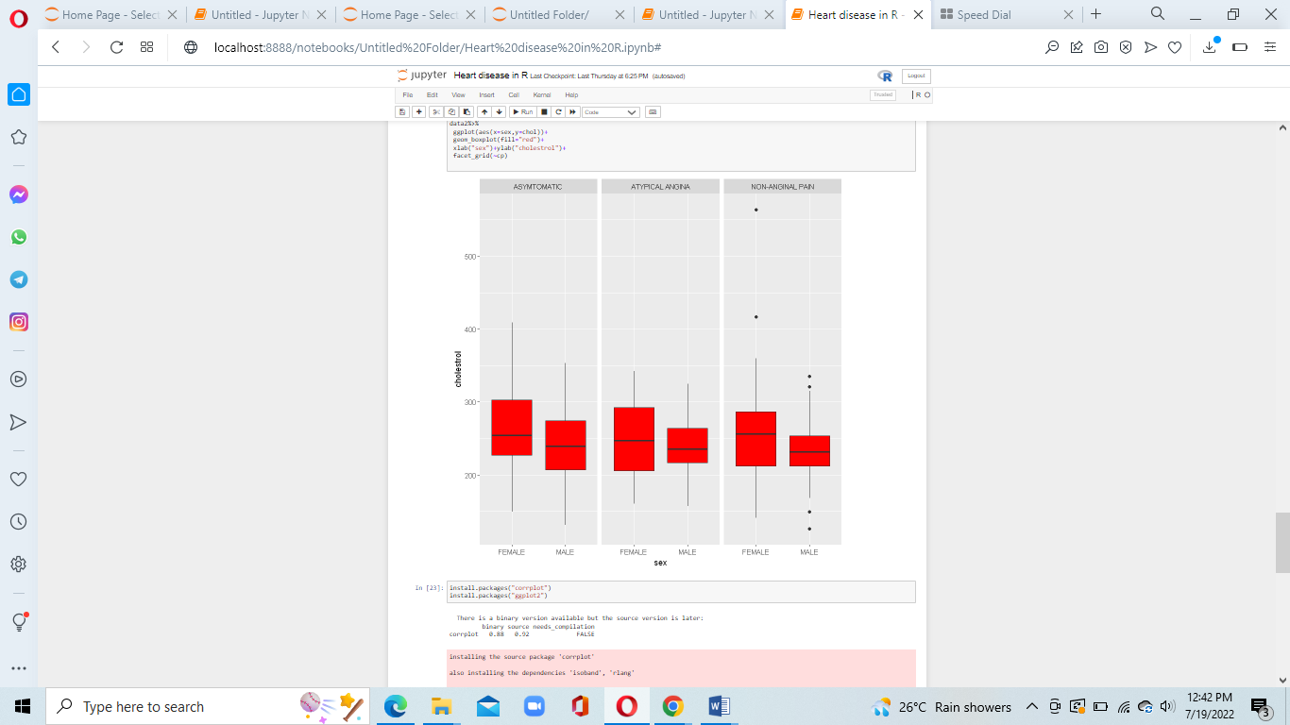

1. Correlation of all the elements with each other

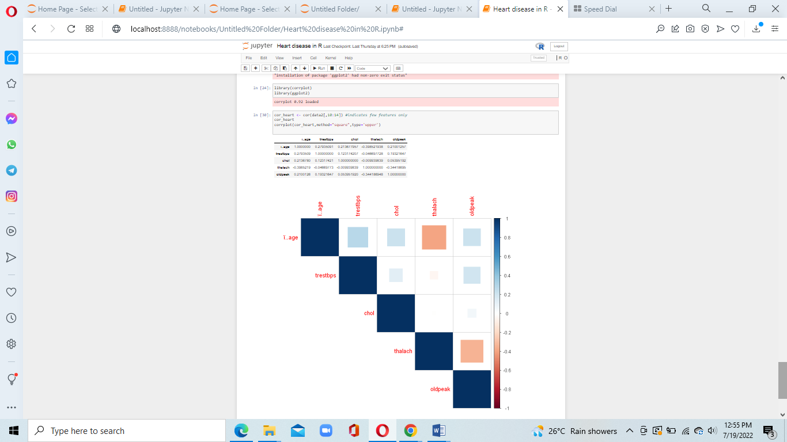

Conclusion

* We discovered that heart disease is a severe problem as a result of our research and study. We discovered that this condition is caused by a variety of variables, learned about the symptoms of various heart illnesses.
* This form of analysis can be a lot helpful in the medical sector.